**Ex1: Hello World RESTful Web Service**

src/main/java/com/cognizant/spring_learn/controller/HelloController.java

package com.cognizant.spring_learn.controller;

import org.slf4j.Logger;

import org.slf4j.LoggerFactory;

import org.springframework.web.bind.annotation.GetMapping;

import org.springframework.web.bind.annotation.RestController;

*@RestController*

public class HelloController {

private static final Logger ***LOGGER*** = LoggerFactory.*getLogger*(HelloController.class);

*@GetMapping*("/hello")

public String sayHello() {

***LOGGER***.debug("START");

String message = "Hello World!!";

***LOGGER***.debug("END");

return message;

}

}

SpringLearnApplication.java

package com.cognizant.spring_learn;

import org.springframework.boot.SpringApplication;

import org.springframework.boot.autoconfigure.SpringBootApplication;

*@SpringBootApplication*

public class SpringLearnApplication {

public static void main(String[] args) {

SpringApplication.*run*(SpringLearnApplication.class, args);

}

}

Application.properties

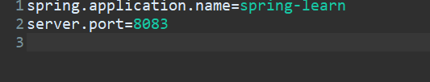

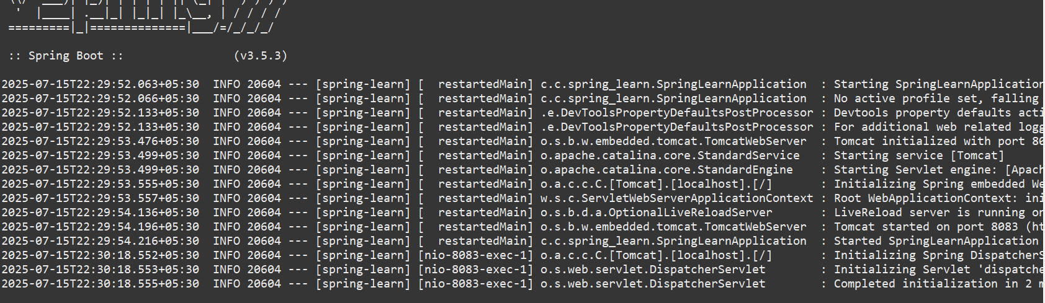

Output

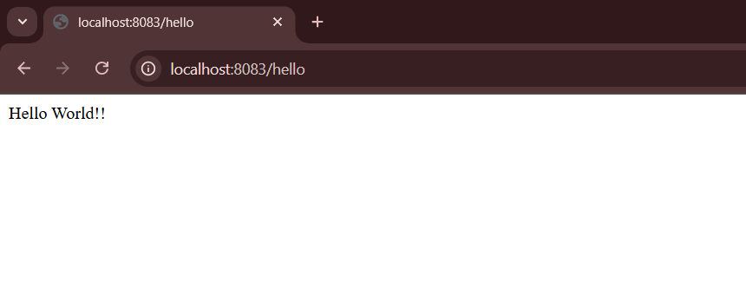

**EX2: REST - Country Web Service**

country.xml

<?**xml** version=*"1.0"* encoding=*"UTF-8"*?>

<**beans** xmlns=*"http://www.springframework.org/schema/beans"*

xmlns:xsi=*"http://www.w3.org/2001/XMLSchema-instance"*

xsi:schemaLocation=*"*

*http://www.springframework.org/schema/beans*

*http://www.springframework.org/schema/beans/spring-beans.xsd"*>

<**bean** id=*"country"* class=*"com.cognizant.spring_learn.Country"*>

<**property** name=*"code"* value=*"IN"* />

<**property** name=*"name"* value=*"India"* />

</**bean**>

</**beans**>

src/main/java/com/cognizant/spring_learn/Country.java

package com.cognizant.spring_learn;

import org.slf4j.Logger;

import org.slf4j.LoggerFactory;

public class Country {

private static final Logger ***LOGGER*** = LoggerFactory.*getLogger*(Country.class);

private String code;

private String name;

public Country() {

***LOGGER***.debug("Inside Country Constructor.");

}

public String getCode() {

***LOGGER***.debug("Inside getCode()");

return code;

}

public void setCode(String code) {

***LOGGER***.debug("Inside setCode()");

this.code = code;

}

public String getName() {

***LOGGER***.debug("Inside getName()");

return name;

}

public void setName(String name) {

***LOGGER***.debug("Inside setName()");

this.name = name;

}

*@Override*

public String toString() {

return "Country [code=" + code + ", name=" + name + "]";

}

}

src/main/java/com/cognizant/spring_learn/controller/CountryController.java

package com.cognizant.spring_learn.controller;

import com.cognizant.spring_learn.Country;

import org.slf4j.Logger;

import org.slf4j.LoggerFactory;

import org.springframework.context.ApplicationContext;

import org.springframework.context.support.ClassPathXmlApplicationContext;

import org.springframework.web.bind.annotation.RequestMapping;

import org.springframework.web.bind.annotation.RestController;

*@RestController*

public class CountryController {

private static final Logger ***LOGGER*** = LoggerFactory.*getLogger*(CountryController.class);

*@RequestMapping*("/country")

public Country getCountryIndia() {

***LOGGER***.debug("START getCountryIndia()");

ApplicationContext context = new ClassPathXmlApplicationContext("country.xml");

Country country = context.getBean("country", Country.class);

***LOGGER***.debug("END getCountryIndia()");

return country;

}

}

SpringLearnApplication.java

package com.cognizant.spring_learn;

import org.slf4j.Logger;

import org.slf4j.LoggerFactory;

import org.springframework.boot.SpringApplication;

import org.springframework.boot.autoconfigure.SpringBootApplication;

*@SpringBootApplication*

public class SpringLearnApplication {

private static final Logger ***LOGGER*** = LoggerFactory.*getLogger*(SpringLearnApplication.class);

public static void main(String[] args) {

***LOGGER***.debug("START");

SpringApplication.*run*(SpringLearnApplication.class, args);

***LOGGER***.debug("END");

}

}

src/main/resources/application.properties

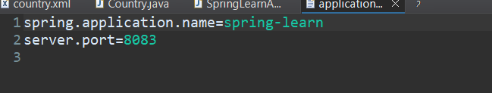

Output

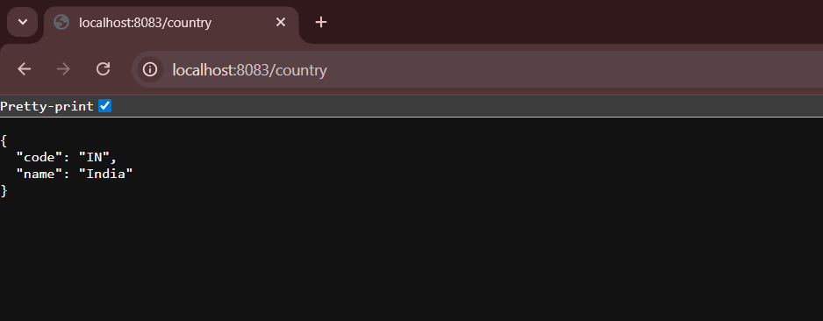

**Ex3: REST - Get country based on country code**

country.xml

<?**xml** version=*"1.0"* encoding=*"UTF-8"*?>

<**beans** xmlns=*"http://www.springframework.org/schema/beans"*

xmlns:xsi=*"http://www.w3.org/2001/XMLSchema-instance"*

xsi:schemaLocation=*"*

*http://www.springframework.org/schema/beans*

*http://www.springframework.org/schema/beans/spring-beans.xsd"*>

<**bean** id=*"countryIN"* class=*"com.cognizant.spring_learn.Country"*>

<**property** name=*"code"* value=*"IN"* />

<**property** name=*"name"* value=*"India"* />

</**bean**>

<**bean** id=*"countryUS"* class=*"com.cognizant.spring_learn.Country"*>

<**property** name=*"code"* value=*"US"* />

<**property** name=*"name"* value=*"United States"* />

</**bean**>

<**bean** id=*"countryDE"* class=*"com.cognizant.spring_learn.Country"*>

<**property** name=*"code"* value=*"DE"* />

<**property** name=*"name"* value=*"Germany"* />

</**bean**>

<**bean** id=*"countryJP"* class=*"com.cognizant.spring_learn.Country"*>

<**property** name=*"code"* value=*"JP"* />

<**property** name=*"name"* value=*"Japan"* />

</**bean**>

<**bean** id=*"countryList"* class=*"java.util.ArrayList"*>

<**constructor-arg**>

<**list**>

<**ref** bean=*"countryIN"*/>

<**ref** bean=*"countryUS"*/>

<**ref** bean=*"countryDE"*/>

<**ref** bean=*"countryJP"*/>

</**list**>

</**constructor-arg**>

</**bean**>

</**beans**>

CountryService.java

package com.cognizant.spring_learn.service;

import com.cognizant.spring_learn.Country;

import org.springframework.context.ApplicationContext;

import org.springframework.context.support.ClassPathXmlApplicationContext;

import org.springframework.stereotype.Service;

import java.util.List;

*@Service*

public class CountryService {

public Country getCountry(String code) {

ApplicationContext context = new ClassPathXmlApplicationContext("country.xml");

List<Country> countries = (List<Country>) context.getBean("countryList");

// Lambda to find match ignoring case

return countries.stream()

.filter(country -> country.getCode().equalsIgnoreCase(code))

.findFirst()

.orElse(null); // or throw exception

}

}

CountryController.java

package com.cognizant.spring_learn.controller;

import com.cognizant.spring_learn.Country;

import com.cognizant.spring_learn.service.CountryService;

import com.cognizant.spring_learn.Country;

import com.cognizant.spring_learn.service.CountryService;

import org.springframework.beans.factory.annotation.Autowired;

import org.springframework.web.bind.annotation.*;

*@RestController*

public class CountryController {

*@Autowired*

private CountryService countryService;

*@GetMapping*("/countries/{code}")

public Country getCountry(*@PathVariable* String code) {

return countryService.getCountry(code);

}

}

Output

http://localhost:8083/countries/in

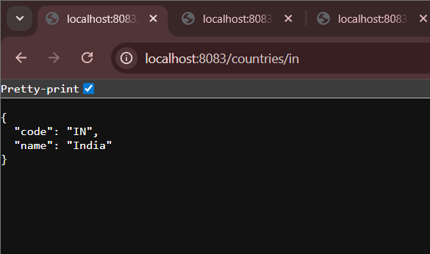

http://localhost:8083/countries/us

